

**FACULTY OF ENGINEERING**

**COMPUTER SCIENCE & ENGINEERING DEPARTMENT**

**CSE3055**

**Database Systems**

**Project Step #3**

**Logical Database Design**

**&**

**Mapping & Physical Design**

**&**

**Database Implementation**

Busenur Yılmaz 150119683

Emirhan Meral 150119649

Ömer Faruk Kışlakçı 150119689

Hüseyin Kerem Mican 150119629

**Project Description**

**Scope**

**Data and Requirements Analysis for The Database and Business Processes**

**Diagram of Whole Database**

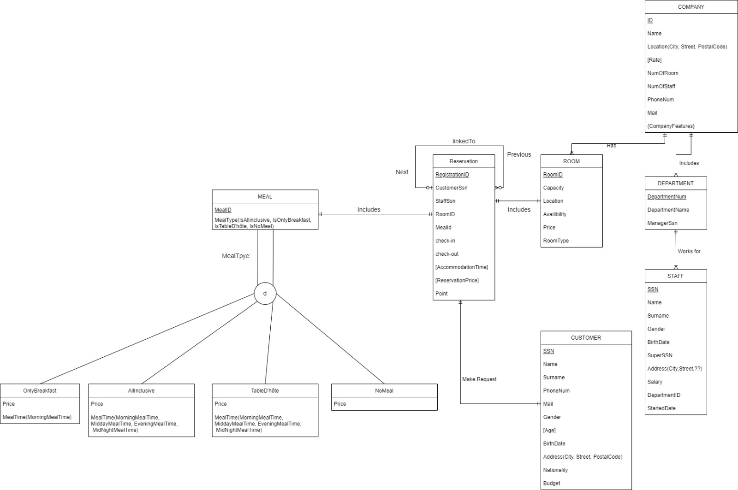

**Tables**

In our database there are tables named as “RESERVATION, ROOM, DEPARTMENT, COMPANY, STAFF, CUSTOMER”.We also have a table named “MEAL” with its subclasses named “ONLYBREAKFAST, ALLINCLUSIVE, TABLED’HOTE and NOMEAL”.

**Views**

**Triggers**

**Stored Procedures**